(Introductory Letter)

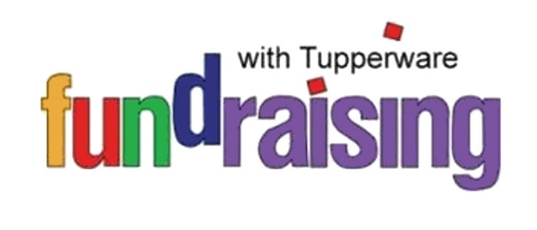

[Date]

Dear [contact name]:

For more than 70 years, Tupperware has provided households around the world with quality products and service, all backed by a trusted name. And now, Tupperware can offer you the same quality and service for your own fundraising campaign.

When you choose Tupperware as your Fundraising partner, you’ll receive quality products, professional sales materials and personalized service. The people who support your organization will receive the same quality products and personalized service they have come to expect from Tupperware.

How will your organization benefit?
- 40% of all retail sales go directly to your organization
- Organization receives payment immediately following the fundraiser.
- Product is delivered about 10 days after the order is placed
- Partnership with a trusted product and name – Tupperware!

I’ve enclosed a sample of our Fundraising brochure and order form so you can see first-hand the quality of the materials your organization will receive.

I’d like to schedule a time to meet with you to discuss your Tupperware Fundraising campaign and how your organization can earn 40% of your total Fundraising sales! I will call you [enter time and date here] to review the program and/or to set a convenient time for us to talk. In the meantime, should you wish to contact me, I can be reached at [phone number].

[Name] thank you for taking time to review the enclosed materials and for considering Tupperware as your Fundraising partner.

Your Tupperware [Manager/Consultant],

[Your name here]
[Your Address here – line 1]
[Your Address here – line 2]
[Your telephone number here]
[Your email address here]

[Goal Letter]

Dear [name]: I’m thrilled you’ve decided to entrust the success of your Fundraiser to me! So we may proceed in a timely manner, please carefully review the following information. If you see areas that need to be changed, please simply note the correct information and initial. Please sign and return this form to me no later than [enter date here] so I can continue the event planning process based on the information provided below.

Organization Name: [enter name here]
Contact: [enter name here]
Telephone Number: [enter number here]
Address: [enter address here]
[enter address here]
[enter address here]

Goal: [enter goal of the Fundraising event here]. [Does the organization wish to raise funds for new uniforms, new toys for daycare, a new van equipped with handicapped features? Be specific so your contact can provide additional information, if necessary]
Profit: [enter name of organization here] will receive 40% of the total sales generated from this Fundraising event (less any applicable taxes and shipping fees).
Program Kick-off: [enter date here] [this may be different than the first day of the program]
Program Dates: [enter dates here]
Number of Packets: [enter number here]
Payment: Payment for Tupperware products can be made with cash, personal check or money order. Make checks payable to [enter organization name here or Consultant name].
Order Pick-Up Date: [enter date(s) here]
Anticipated Delivery: Two to three weeks following submission of order.

[Name], I know you’ll be pleased with the results of having Tupperware as your Fundraising partner. Should you for any reason need to cancel your event, please let me know. If we reschedule your event within three (3) months of the initial cancellation, there will not be a restocking fee assessed. Fundraisers cancelled after the materials have been contributed will be assessed a $100 materials/processing fee and any other associated product or materials costs.

Thank you,

____________________________________ _________________________________
[Your name here] [Date] [Enter contact’s name here] [Date]

____________________________________ _________________________________
[Your telephone number here] [Enter organization’s name here]

[Letter to Event Participant]

Welcome to Your Fundraising Event!

As a participant in a Tupperware Fundraising program for [enter organization’s name here] you’ll have the opportunity to see quality Tupperware brand products backed by a full lifetime warranty and help [enter organization’s name here] achieve its Fundraising goals.

Attached is a product brochure and a collection/information envelope. Before you start asking your family, friends, neighbors and/or business associates, please take a moment to look over the instructions (printed on the envelope) as well as the brochure. We’re confident you’ll find the array of products will satisfy your customer’s product needs.

Always make sure the order form is correctly completed and payment is received with each order taken. You should have your order forms and payments ready by [enter day here] to turn into your Fundraising Event Chairman, [enter name here].

If I can provide you with any answers to your questions or offer additional assistance, please do not hesitate to call on me. You can reach me at [enter your telephone number here] or by email at [enter email address here].

Thank you, good luck and have fun! Together, we will make a difference!

Your Tupperware [Manager/Consultant],

[Your Name Here]
[Your Address here – line 1]
[Your Address here – line 2]
[Your telephone number here]
[Your email address here]

[Fundraising Event Organization Name]
[Dates of Fundraising Event]
[Orders/money to be turned in by date here]

[Thank you letter to Contact]

[Date]
Dear [contact name],

Congratulations on the success of your Fundraising event! It was a pleasure having the opportunity to provide you with a quality product with a full lifetime warranty and personalized service. I can truly say that together, we made a difference!
If I can be of further service, please do not hesitate to call on me. I hope we have the opportunity to work together on your next Fundraising event, and, I would appreciate you referring me to other Fundraising executives in the community. I would welcome the opportunity to provide other quality organizations with a results-proven Tupperware Fundraising Campaign.

[Contact Name], thank you for making Tupperware your Fundraising partner!

Your Tupperware [Manager/Consultant],
[Your Name Here] [Your Address here – line 1]
[Your Address here – line 2]
[Your telephone number here]
[Your email address here]

