Step | Activity | When | Script | Meme
1 | Thank you | Upon booking | I am so excited to be working with you for your Tupperware party! I know we will have FUN, and I’ll do my best to snag you everything you want off your wish list. I have a super simple system, and if you trust me and follow the steps, your party will be a success. Ready to hop to it? | 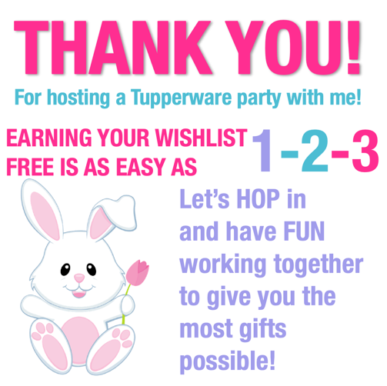
2 |  | As soon as she replies to your question | Perfect! For me all Tupperware parties are a good time, but the BEST Tupperware parties are the ones where YOU earn as much as we can snag off your wish list. In your packet was a flyer that showed current host offers. Or you can select items from the catalog. Do you already know what you’re hoping to earn?
3a | Responds YES | As soon as she replies YES to your question in step 2 | Awesome! This step will be super easy for you. All I need you to do is send me a wish list of 10 (or more!) items that you’d like to enjoy FREE from Tupperware. If you have anything you’d be willing to pay ½ price for, mark those items with a *  RETURN YOUR WISH LIST WITHIN 24 HOURS, AND YOU’LL EARN YOUR FIRST BONUS GIFT FROM ME!  Here’s a link to see our catalog.  http://catalog.tupperware.com/catalog/summer/ | 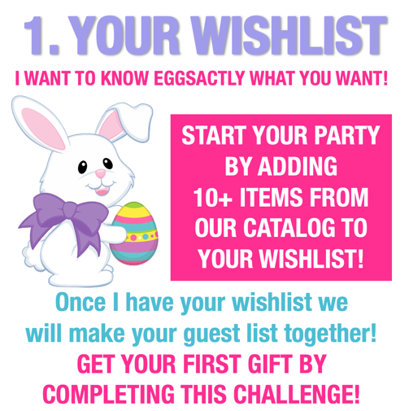
3b | Responds NO | As soon as she replies NO to your question in step 2 | Yeah! This will feel like Christmas shopping for you…without the guilt or the bill! Simply check out our full line catalog, and make a list of 10 (or more!) items that you’d like to enjoy FREE from Tupperware. If you have anything you’d be willing to pay ½ price for, mark those items with a *  RETURN YOUR WISH LIST WITHIN 24 HOURS, AND YOU’LL EARN YOUR FIRST BONUS GIFT FROM ME!  Here’s a quick link to the catalog, so you can check out all of the goodies you can enjoy FREE as a host.  http://catalog.tupperware.com/catalog/summer/
4 |  | Once she returns her wish list (be sure you follow up around hour 18 if you haven’t heard back yet!) | You have SO many great goodies on here! I am so excited to partner with you for this party! Looking at your wish list, I do think you should consider joining my team as a personal shopper or a business builder. The membership fee is just $15 and that will give you 25% off any order you place during this party or after it has closed, for an entire year! We can easily convert your party to your first party as a Consultant, and that will give you ALL of the host benefits from Tupperware. Just like with me as a Consultant) PLUS you’d earn the sales credit which will earn you some additional gifts. Can I send you some more information so you can think about it?
5a | Send her the kit info. | As soon as she replies YES to your question in step 4 | We have two kit option No matter which you choose, you’ll have all of the same benefits, including a discount of 25% (or more!) on every purchase for a year. As always, no pressure! I just know it’s the best deal Tupperware has to offer and I would love to help you snag their best offers. Think about it and if you decide YES, this can be your first party!
5b |  | As soon as she replies NO to your question in step 4 | No worries! If you change your mind at any point, let me know and I’ll send you everything so you can look it over. I’m also happy to send it over if you have a friend who might want or need to save some money.  Did you get a chance to peek at the Host Gift Specials in the catalog?
6 | Send Host Gift Special Meme | Immediately after 5 | Here is a beautiful set that will help you maximize your host credit. The way our benefits work is you’ll begin earning “host credit” once your party exceeds $300 in sales. That host credit can be spent on anything you’d like from our full catalog (which is why I had you make your wish list from there). However, if you’ like to apply your host credit towards a host gift special, you’ll end up with about twice as much in product vs. a shopping spree. What do you think about this set? | 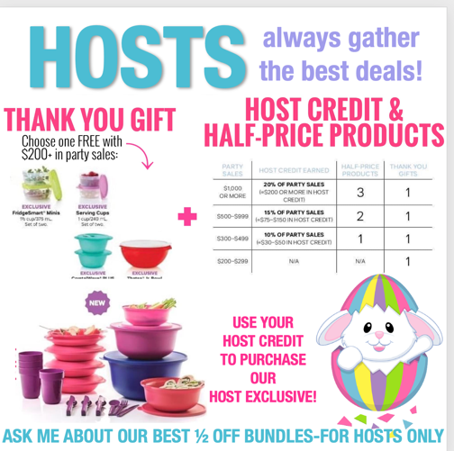
7 |  | Once she has responded to #6 | Well, it’s time for us to hustle! Don’t worry—this is where your party gets really FUN…because it’s time to think about your FRIENDS. A guest list of 50 people will be about right for earning the goodies you’ve chosen and I want to make sure I help you think of who to invite.  Of course, everyone who eats NEEDS Tupperware, but here’s a few categories I think might help you narrow your list down to friends and family who:  *want a healthy lifestyle  *Like to feel organized  *Look for deals/like to save money  *are environmentally conscious  *loves Tupperware already!  This is just a guide to help you get started. Try to keep your invite list to 40. We want to keep your event exclusive and I want you to have a chance to connect with friends.  P.S. Don’t message anyone yet—I’ve got some great word choices and it’s important we do it together! | 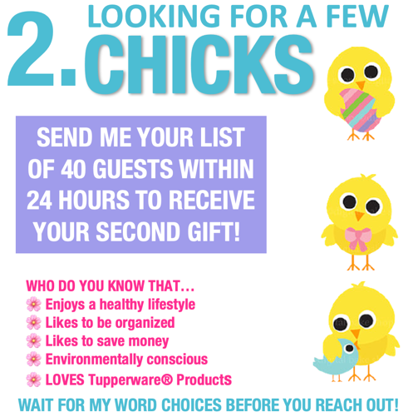
8 | Add her to the private group you have created | Once she has returned her guest list (remind her if she’s 18+ hours and hasn’t replied | Love it! Gathering people for food, fun, friendships and freebies really is a great way to unwind from the stress of everyday life.  Inviting is simple. You can copy and paste the script below, but try to add their name to make them feel special. Feel free to tweak it if you’d like, but be sure you are using private messageing ONLY and asking permission to invite them to the group. Those two things are so important! I recommend that you only invite 10 at a time. FB has been know to suspend accounts if you copy and paste rapidly and to lots of people.  Here’s a simple way to invite:  Hi!  I’m not sure if you’ve heard, but I’m having a Tupperware get together right here on Facebook on ____. Can I send you a link to the group so you can check out the details and check your calendar?  ****WAIT FOR HER TO REPLY***Once she replies YES, say:  Awesome! Here’s a link to the group, and if you have any questions, just let me know. If I don’t know the answer , my Consultant will!  ***insert group link***
9 |  | Once you start seeing guests added to the group | Things are hopping in your group! There’s a possibility that some of your friends will be unable to come. If so be sure and ask them if they’d like to hold a party during a better time, because that will help you earn your Host Gift Specials. IF THEY AREN’T INTERESTED IN A PARTY, THEY CAN PLACE AN ORDER—YOU’RE LOOKING FOR 5 ORDERS PRIOR TO THE PARTY TO EARN YOUR THIRD GIFT FROM ME! | 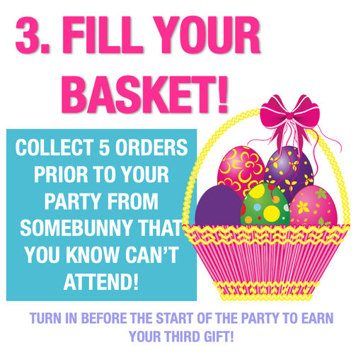
10 |  | Day before | Today is a good day to double check the list of “members” in your party and see who hasn’t accepted. They may need a little help if they don’t know how to accept the invite to the group. They may also realize that they aren’t available to attend. No worries, they can check out all the posts and participate in the give-aways.  For the guest who have joined us, I’ve posted in the group a few pics of how to turn on their notifications. Please be sure and tag them so they know they are in the right place, and they know how to switch their settings.  Speaking of tagging, as I start posting, if you see anything you’re interested in or anything you feel someone else might like, be sure and tag the with a few words sharing WHY you tagged them. | 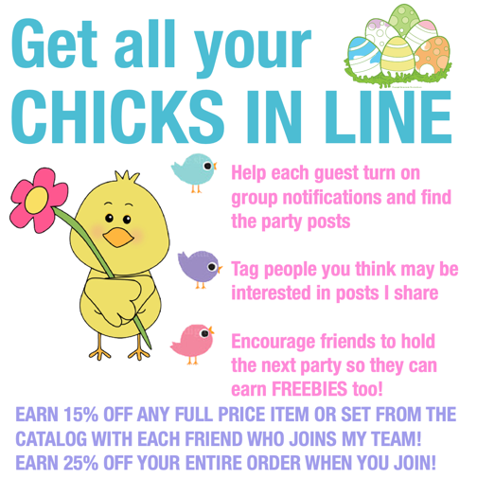
11 |  | Day before party | You have everything you need to ROCK OUT this party and I just know it will be a success! I can’t wait to party with you on _____ t and wrap it all up on ________!

